

**N**ational **I**nstitute for **M**aterials **S**cience

Sengen 1-2-1, Tsukuba, Ibaraki 305-0047, JAPAN Tel: (81)29-859-2751

11th August 2025

Dr. Shigeki Kawai

1-2-1, Tsukuba, National Institute for Materials Science

Ibaraki, 305-0047, Japan

# Certificate of Attendance to NC-AFM2025

Dear Dr. Shigeki Kawai:

We hereby confirm your participation in the 26th International Conference on Non-contact Atomic Force Microscopy (NC-AFM2025), which took place in Toyama, Japan, from August 3 to 8, 2025.

This conference is part of a series of international conferences devoted to the latest progress in dynamical atomic force microscopy. It covers experimental, theoretical, and instrumental developments in frequency modulation and other dynamic operation modes with particular emphasis on aspects of high-resolution imaging and force spectroscopy.

https://www.nims.go.jp/group/Nanoprobe/NC-AFM2025/Index.html

Sincerely,

署名/Signature

Shigeki KAWAI, Conference Chair of NC-AFM 2025

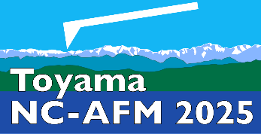Assoc. Prof. Dr, Group Leader

Nanoprobe Group, Center for Basic Research on Materials,

National Institute for Materials Science (NIMS)

KAWAI.Shigeki@nims.go.jp